SmartPlant 3D Electrical Reference Data
User Training Exercises

Table of Contents

Table of Contents 2
LAB-1: Placing Parametric Equipment 3
LAB-2: Rotating Equipment While Placing / After Placement 9
LAB-3: Placing Designed Equipment and Equipment Component 12
LAB-4: Placing Equipment with Mate Relationship 15
LAB-5: Equipment Modification 17
LAB-6: Move / Copy / Paste Equipment 18
LAB-7: Placing shapes to Build Designed Equipment 20
LAB-8: Placing Nozzles 27
LAB-9: Importing Equipment from External Modeler 31
LAB-10: Equipment from Shapes and Components 33
LAB-11: Placing Equipment from P&ID 42

LAB-1: Creating a Cableway Specification

The cableway reference data contains specifications and rules. Cableway does not include part
definitions in the reference data because cableway is a space reservation in the model and does
not have physical parts.

- Copy CableWay.xls workbook from
C:\Program Files\SmartPlant\3D\CatalogData\BulkLoad\DataFiles
into a working folder like C:\LABS
- Remove read-only attribute and open the CableWay.xls workbook
- Select the CablewaySpec sheet
- Define a new spec in the row below the delivered spec Cws-0. Use the parameters shown. Notice that values for material, tray, and manufacturer are not defined because this cableway definition will be used to reserve empty spaces, and not to model physical parts.
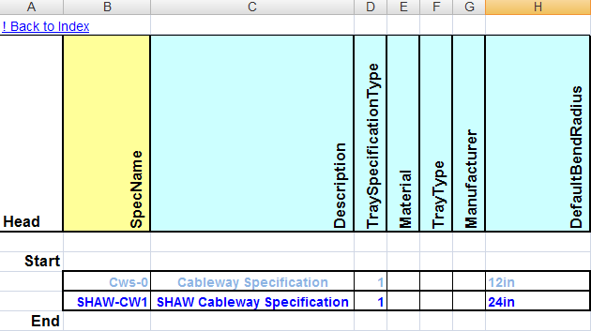
Note: The expanded value of the code listed attribute “TraySpecificationType” came from the AllCodelists.xls workbook. The possible values there are:
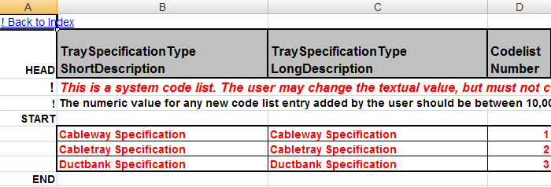
- Type an “A” in the first column of the new spec. This will cause the line to be bulkloaded into the catalog database.
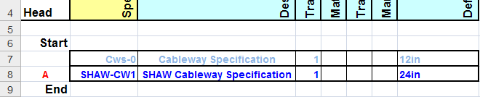
- Open worksheet CableWayNominalSizes in the same workbook
- Copy the Rectangular and Round cross sections for Cws-0 and insert them below the Cws-0 cross sections list
- Set the spec name in column B to SHAW-CW1 to reflect the correct spec name. Retain all the same cross section sizes.
Note. To define other sizes, the worksheet named OutfittingCrossSections must be edited to include them and Bulkloaded to the catalog. This sheet is found in the AllCommon.xls workbook.
- Add an “A” in the first column to cause the Bulkload process to add these rows to the catalog
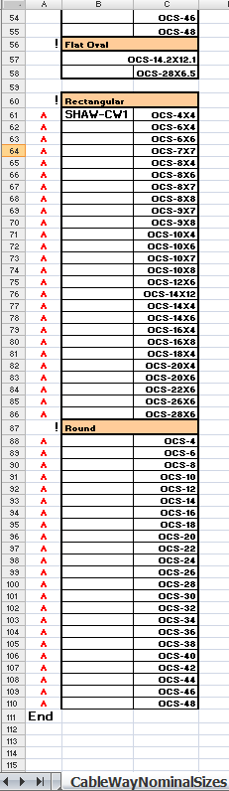
- Open worksheet CableWayBendRadius in the same workbook
- Copy the radii table for Cws-0 and insert it below the Cws-0 list
- Change the spec name to SHAW-CW1 and insert “A” in the first column as shown
- Add a new row for BendRadius equal to 0
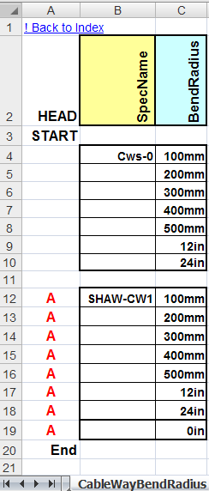
- Save and exit the workbook
- Launch the Bulkload utility in Start>Programs>Intergraph SmartPlant 3D>Database Tools>Bulkload Reference Data
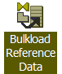
- Set the bulkload parameters as shown below to process workbook CableWay.xls. Instructor or CAE should provide you the server name, catalog (CDB) database name and schema, as well as the Symbols share name for your training location
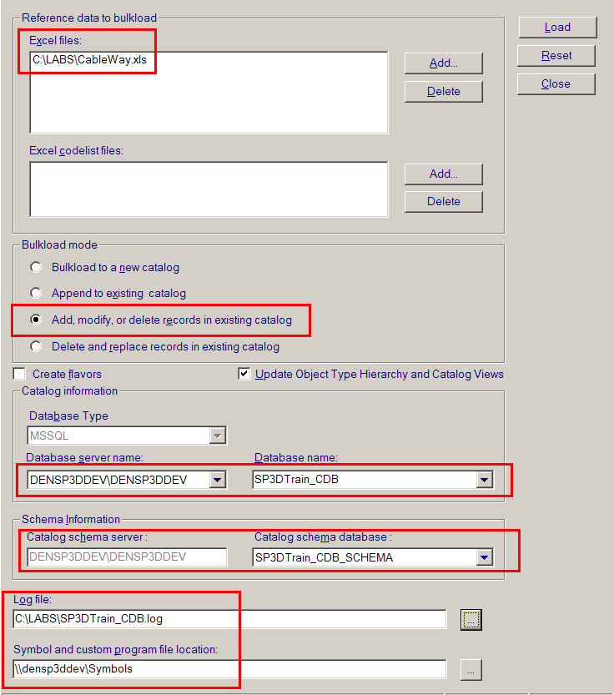
- Verify that the bulkload was successful. If errors are reported, open the log file, review the problem, repair any issues with your worksheets entries, save/exit, and click “Load” to try again.
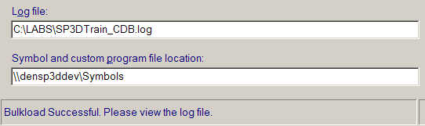
- Once successful, enter an SP3D design session to test cableway SHAW-CW1
- In the 3D environment, select Tasks>Systems and Specifications
- Select the plant name from the left panel, eg. SP3DTrain
- From the ribbon menu select the “Define Allowed Specifications” button
- Click the + to expand the Cableway node in the form that appeared
- Select the spec SHAW-CW1 and Add>> to make available to the design sessions
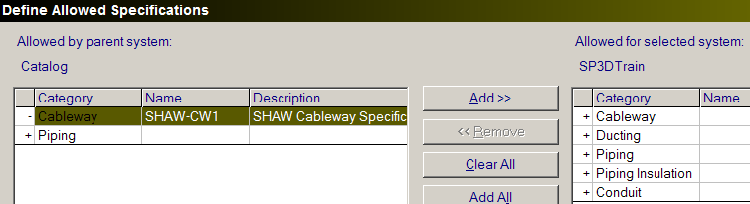
- Verify that the new spec is now listed with the allowed specs:
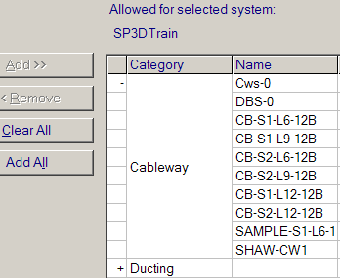
- Click OK on the allowed specifications form
- Select Tasks>Electrical to model the test cableway
- Select the Route Cableway command
- Select a starting location (A point on an existing grid line is a good place to start)
- On the New Cableway form that appears, define the system and set the specification to SHAW-CW1 and OK
- Make sure the cross section shape option is set to Rectangle
- For the Width select 8in
- Enter a Depth of 4in
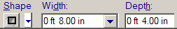
- Route a straight section by clicking on the screen
- With route still active, select the properties option
- In the form’s Defaults tab, make sure the ThroatRadius is set to 2ft and Turn Type to Bend and OK
- Click on the screen to place a 90 degree turn
- Activate the properties form again
- In the form’s Defaults tab, set the ThroatRadius to 0ft and OK
- Click the screen to place another run at 90 degrees

- Select the Route Cableway command again
- Click the work area for a starting point
- Click OK on the New Cableway form
- Change the cross section shape to Round
- Set the Diameter to 6in 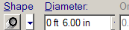
- Click the work area to place a straight section
- Place another straight section at 90 degrees
- Open the properties form and change the bend radius to any other value of your choice
- Click for placement of another leg creating a 90deg turn. Notice the turn radius change
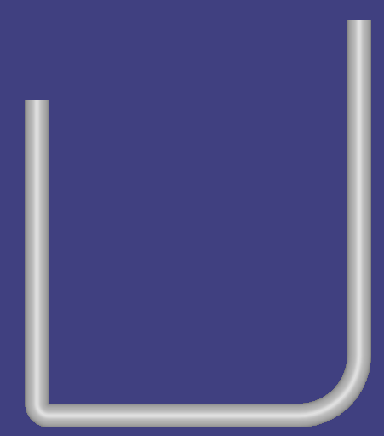
Note. Remember that this is not conduit, just reserved space
- Select the Route Cableway command
- Select a starting location
- On the New Cableway form that appears, keep the specification to SHAW-CW1 and OK
- Make sure the cross section shape option is set to Rectangle
- For the Width select 1ft
- Enter a Depth of 4in
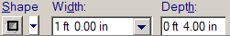
- Route a straight section by clicking on the screen
- With route still active, select the properties option
- In the form’s Defaults tab, set the Turn Type to Miter, No of Miters enter 1, and OK
- Click on the screen to place a 90 degree turn
- Go back to properties and set No of Miters to 2 and OK
- Click on the screen to place another 90 degree turn
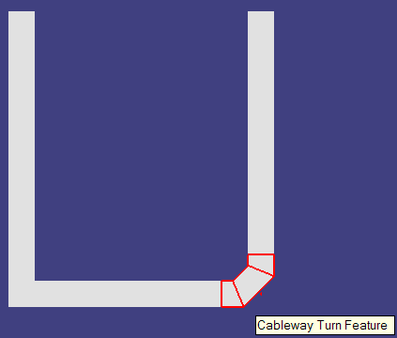
Cableway with miter turns

LAB-2: Creating a Duct Bank Specification

- Copy Ductbank.xls workbook from
C:\Program Files\SmartPlant\3D\CatalogData\BulkLoad\DataFiles
into a working folder like C:\LABS
- Remove read-only attribute and open the Ductbank.xls workbook
- Select the CablewaySpec sheet
- Define a new spec in the row below the delivered spec DBS-0. Use the parameters shown.
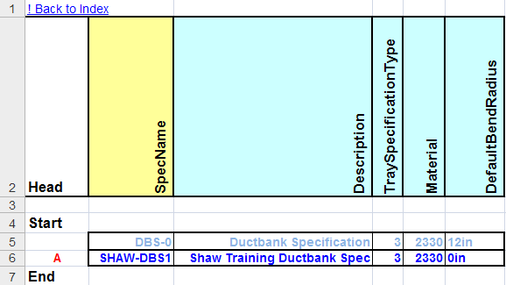
Note. Validate Tray Specification Type and Material in the code lists workbook AllCodelists.xls. The “material” code list values are found in worksheet MaterialsType.
- Open worksheet CableWayNominalSizes in the same workbook
- Copy the Rectangular cross sections for DBS-0 and insert them below before the End keyword
- Set the spec name in column B to SHAW-DBS1 to reflect the correct spec name. Retain all the same cross section sizes.
Note. To define other sizes, the worksheet named OutfittingCrossSections must be edited to include them and Bulkloaded to the catalog. This sheet is found in the AllCommon.xls workbook.
- Add an “A” in the first column to cause the Bulkload process to add these rows to the catalog
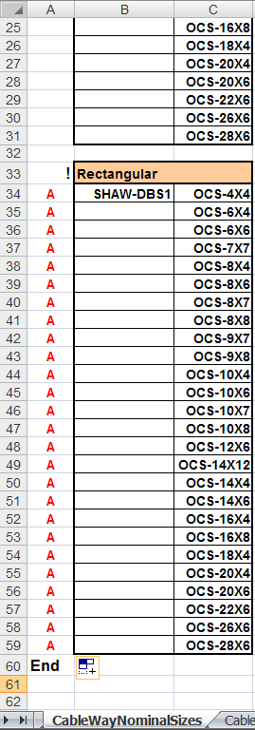
- Open worksheet CableWayBendRadius in the same workbook
- Copy the radii table for DBS-0 and insert it below the original list
- Change the spec name to SHAW-DBS1
- Add a new row for BendRadius equal to 0
- Set the first column to “A” as shown
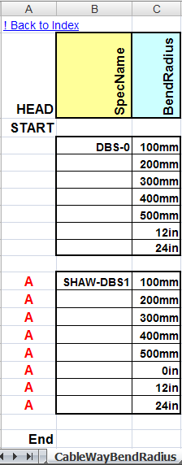
- Save and exit the workbook
- Launch the Bulkload utility in Start>Programs>Intergraph SmartPlant 3D>Database Tools>Bulkload Reference Data
- Set bulkload to load the workbook Ductbank.xls. The instructor or CAE should provide the database, schema, and symbol share information you need.
- Once bulkload is successful, enter your SP3D design session to test the Duct Bank
- In the 3D environment, select Tasks>Systems and Specifications
- Select the plant name from the left panel, eg. SP3DTrain
- From the ribbon menu select the “Define Allowed Specifications” button
- In the “Allow Specs” form, make the duct bank spec “SHAW-DBS1” allowable for placement in the plant
- Return to the Electrical task and select the Route Cableway command
- Define a starting point
- When the New Cableway form appears, set the Specification to SHAW-DBS1
- Select the Duct Bank tab (new in v2009)
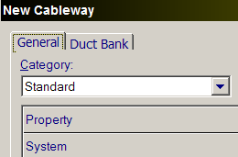
- Review the default cross section and conduit information
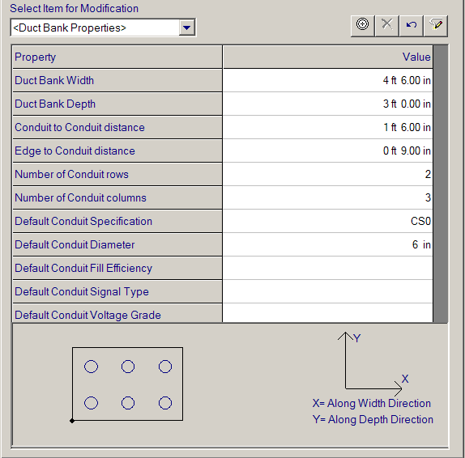
- Click the pulldown menu for <Duct Bank Properties> and select Run1x1
- Review the conduit parameters. This form allows the user to set conduit size, spec, x-y location in the duct bank etc. for each conduit run that will populate the inside of the bank. Notice the location of the conduit highlighted in red in the section diagram. Leave parameters as they are, after reviewing them select OK
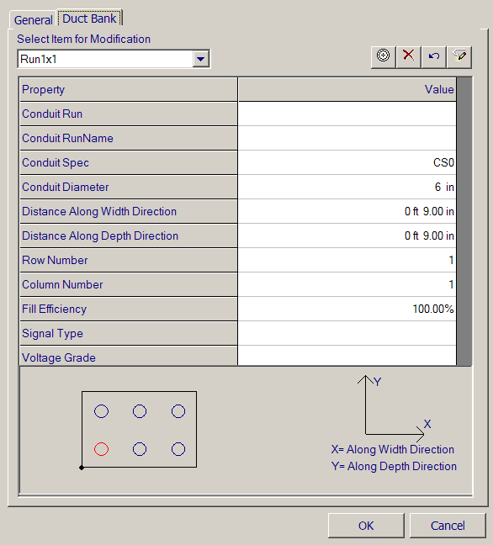
- Click on the workspace as needed to place two legs of Duct Bank at 90 degrees
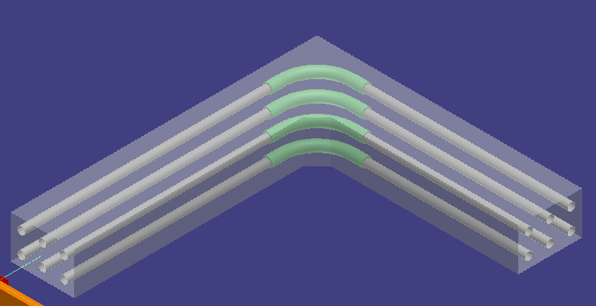
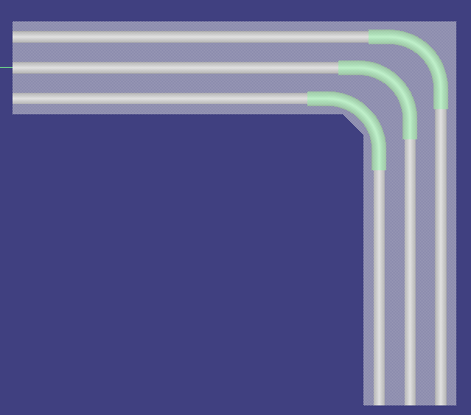
- Exit route and select the duct bank to review properties to verify that SHAW-DBS1 spec was used
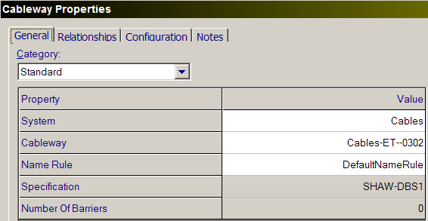

LAB-3: Creating a Cable Tray Specification
- Copy CableTray.xls workbook from
C:\Program Files\SmartPlant\3D\CatalogData\BulkLoad\DataFiles
into a working folder like C:\LABS
- Remove read-only attribute and open the CableTray.xls workbook
- Select the CabletraySpec sheet
- Define a new spec named SHAW-TRAY in the row below the delivered spec CB-S2-L12-12B. Use the parameters shown below or define your own.
  - See worksheet Manufacturer in AllCodelists.xls for possible values for The Manufacturer column
  - See worksheet CableTrayMaterials in AllCodelists.xls for possible values for Material column
  - See worksheet CableTrayType in AllCodelists.xls for possible values for TrayType column
  - See worksheet LoadSpanClassification in AllCodelists.xls for possible values for LoadSpanClassification column
  - See worksheet TraySpecificationType in AllCodelists.xls for possible values for TraySpecificationType column
  - See worksheet CableTrayComponentType in AllCodelists.xls for possible values for connection parts (Columns M-AD).
Note: For this exercise connection implied items will be left blank.
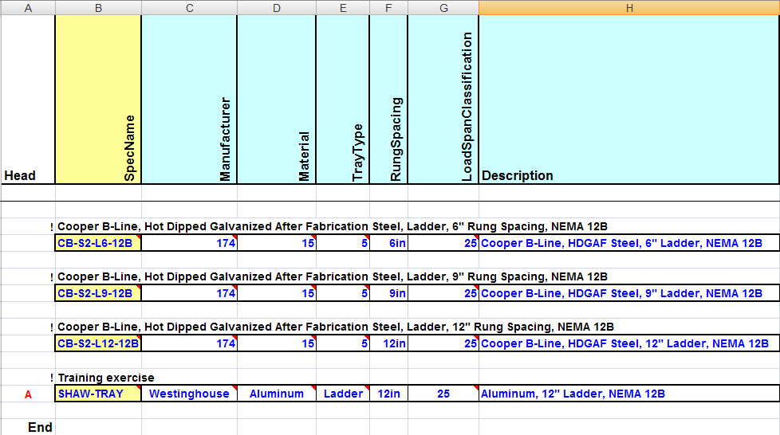
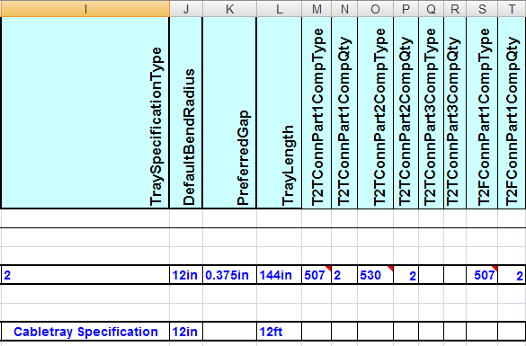
Important: Notice that code listed attributes can be entered as a number, or as the spelled out word(s) the number represents. Entering character string values for code listed attributes is allowed as long as those values do exist in the code list library.
- Insert an “A” in the first column for bulkload to process this line in Add/Mod/Del mode
- Save and exit the workbook
- Launch the Bulkload utility in Start>Programs>Intergraph SmartPlant 3D>Database Tools>Bulkload Reference Data
- Set bulkload to load the workbook CableTray.xls. The instructor or CAE should provide the database, schema, and symbol share information you need.
- If errors are reported by Bulkload, review the log file, repair the cable tray workbook as needed and use Load again
- Once bulkload is successful, proceed to the next lab exercise to define cable tray parts that will be placed by the new spec.

LAB-4: Defining Cable Tray Straight Sections
- Open the CableTray.xls workbook and go to the Straight worksheet
- Define the straight tray attributes.
IMPORTANT: The tray parts are linked to their parent spec not through the spec name, but through a combination of attributes: Manufacturer, Material, Tray Type, load span classification, and bend radius
- Define straight tray for spec SHAW-TRAY for sizes 12in, 18in, and 24in and depth of 4in
  - Copy the part definitions for 12-24 inch straight sections from one of the Intergraph delivered Cooper B-Line specs and insert them below the Start keyword
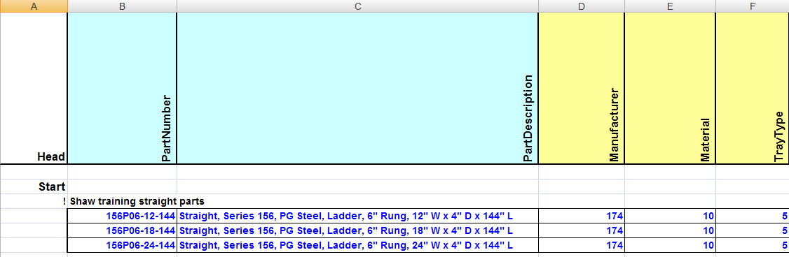
  - Edit the straight parts attributes to match your spec. Use the CabletraySpec worksheet as reference for key information required (Manufacturer, Material, tray type, etc.)
  - A generic name will be used for PartNumber. Later labs will deal with using a naming convention for PartNumber.
  - See worksheet CableTrayComponentType in AllCodelists.xls for possible values for ComponentType column
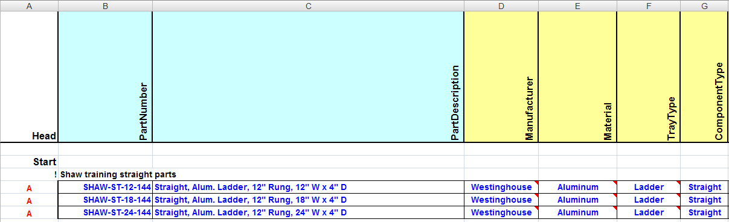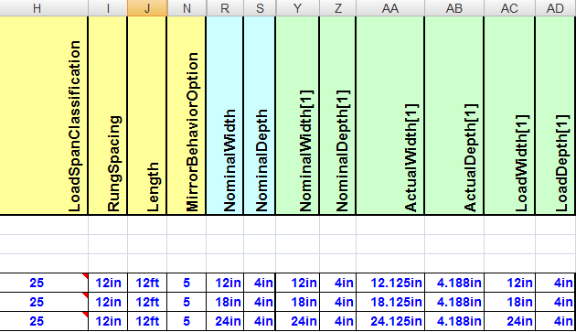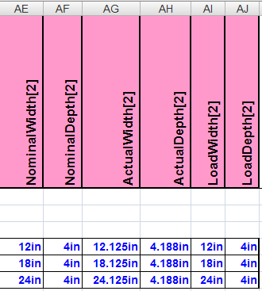
  - Make sure to add an “A” in the first column for Bulkload processing
  - Save and exit the workbook
  - Launch the Bulkload utility
  - Have bulkload load the workbook CableTray.xls in Add/Modify/Delete mode
  - If errors are reported by Bulkload, review the log file, repair the cable tray workbook as needed and use Load again
  - Once bulkload is successful, proceed to the next lab exercise to define additional cable tray parts that will be placed by the new spec.

LAB-5: Defining Cable Tray Bends
- Open the CableTray.xls workbook and go to the CT90HBend worksheet
- Define the 90 deg horizontal bend tray attributes.
IMPORTANT: The tray parts are linked to their parent spec not through the spec name, but through a combination of attributes: Manufacturer, Material, Tray Type, load span classification, and bend radius. Copy these attributes from the Straight worksheet to simplify the process of defining these bends.
  - Copy the part definitions for 12-24 inch 90-degree horizontal bends sections from one of the Intergraph delivered Cooper B-Line specs and insert them below the Start keyword
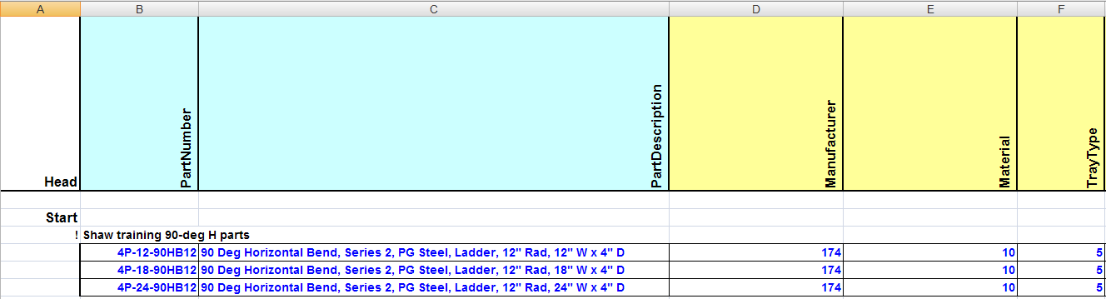
  - Edit the horizontal bend parts attributes to match your spec. Use the CabletraySpec worksheet as reference for key information required (Manufacturer, Material, tray type, etc.)
  - A generic name will be used for PartNumber. Later labs will deal with using a naming convention for PartNumber.
  - See worksheet CableTrayComponentType in AllCodelists.xls for possible values for ComponentType column
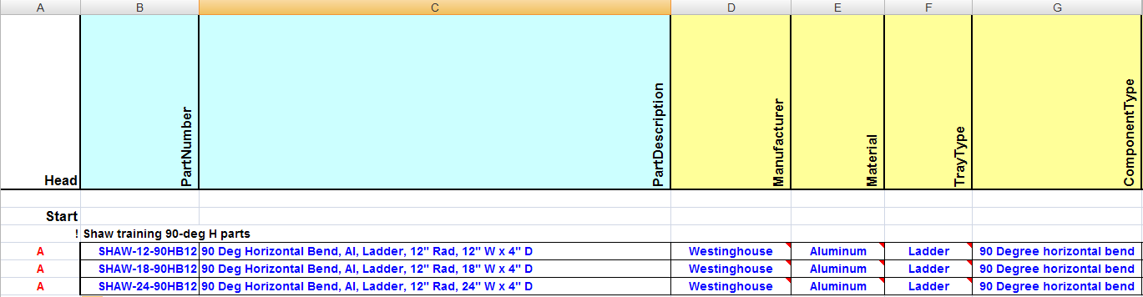
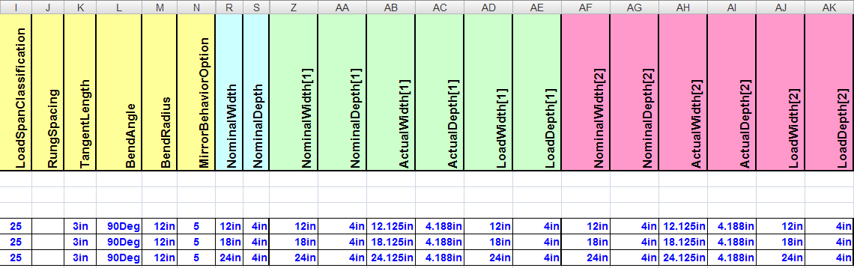
  - Make sure to add an “A” in the first column for Bulkload processing
  - Save and exit the workbook
  - Launch the Bulkload utility
  - Have bulkload load the workbook CableTray.xls in Add/Modify/Delete mode
  - If errors are reported by Bulkload, review the log file, repair the cable tray workbook as needed and use Load again
- Open the CableTray.xls workbook and go to the CT90VIBend worksheet
- Define the 90 deg vertical inside bend tray attributes.
  - Copy the part definitions for 12-24 inch 90-degree vertical inside bends from one of the Intergraph delivered Cooper B-Line specs and insert them below the Start keyword

  - Edit the vertical bend parts attributes to match your spec.
  - A generic name will be used for PartNumber as shown below
  - See worksheet CableTrayComponentType in AllCodelists.xls for possible values for ComponentType column
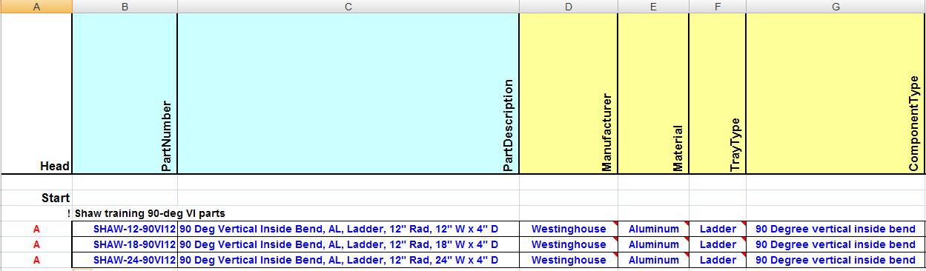
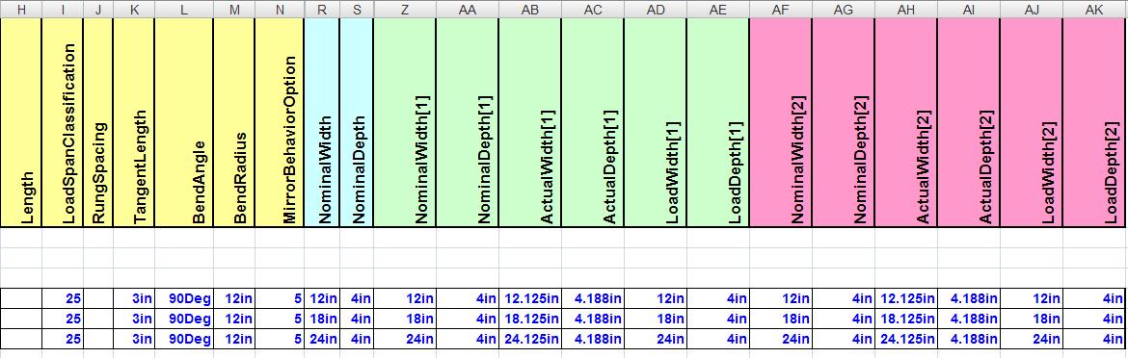
  - Make sure to add an “A” in the first column for Bulkload processing
  - Save the workbook
- Repeat the steps above to create “SHAW” parts for 90 degree vertical-outside bends. Make your edits in worksheet CT90VOBend similar to the edits above
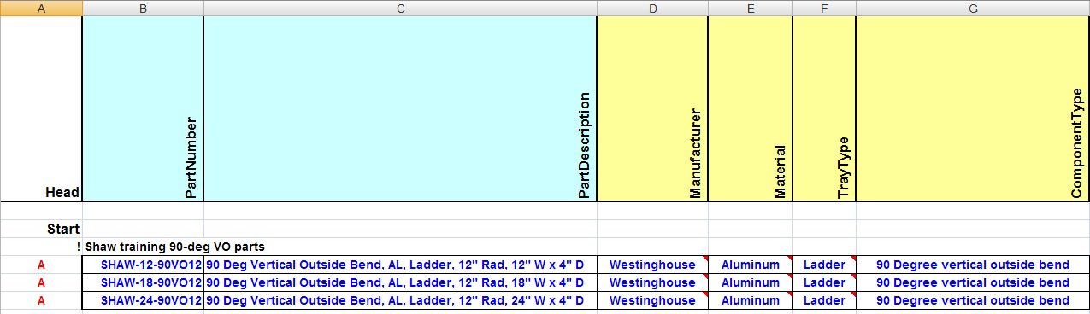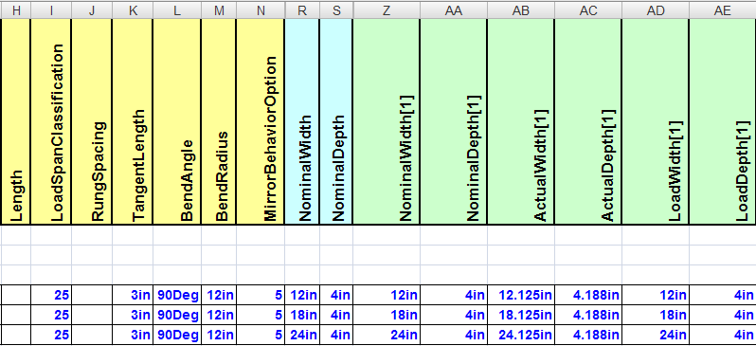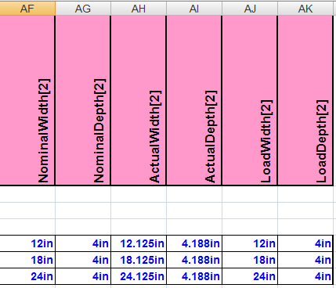
  - Save and exit the workbook
  - Launch the Bulkload utility
  - Have bulkload load the workbook CableTray.xls in Add/Modify/Delete mode
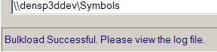
  - Once Bulkload is successful, start a fresh SP3D session
- In SP3D session, go to the Systems and Specifications task
- Select the plant name and use the Allowed Specifications option to allow the use of the new cable tray spec defined in this exercise
- Go to the Electrical task
- Select Route Cableway command
- Click in the workspace to define a starting point
- In the New Cableway form that appears, select the new spec SHAW-TRAY and OK
- Make sure that the tray widths are available per the spec in 12in, 18in, and 24in; and set Depth to 4in
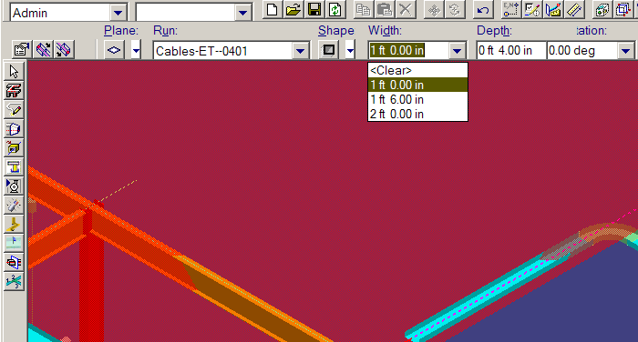
- Go to the attributes form , make sure that Turn Type is set to Bend in the Defaults tab and OK
- Insert a couple of legs of tray at 90-degrees in the Horizontal and also the Vertical planes. Components should be automatic
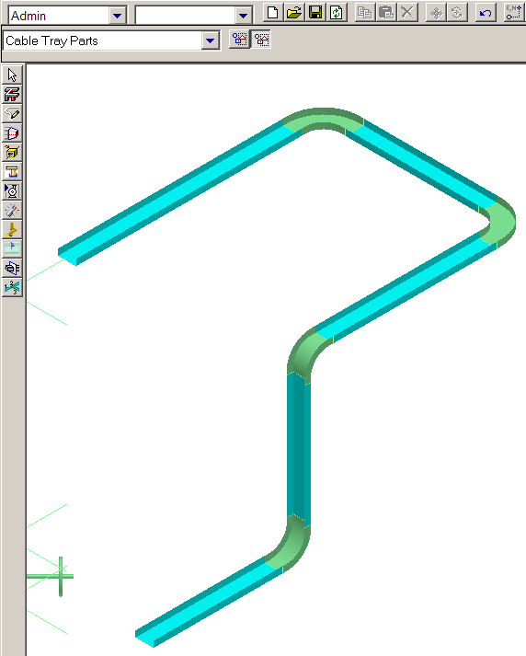
- Set the locate Filter to Cable Tray Parts
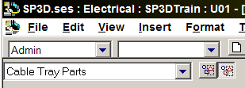
- Select any of the 90 degree bends just placed and review its properties. In the Definition tab, verify that Part Number, Part Description, etc. are as they were defined in the Excel workbook before Bulkload
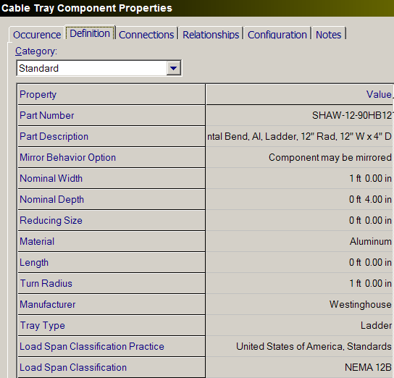

LAB-6: Building Cable Tray Spec from Vendor Catalog

Create a cable tray specification with the following data
Specification provided by Square D

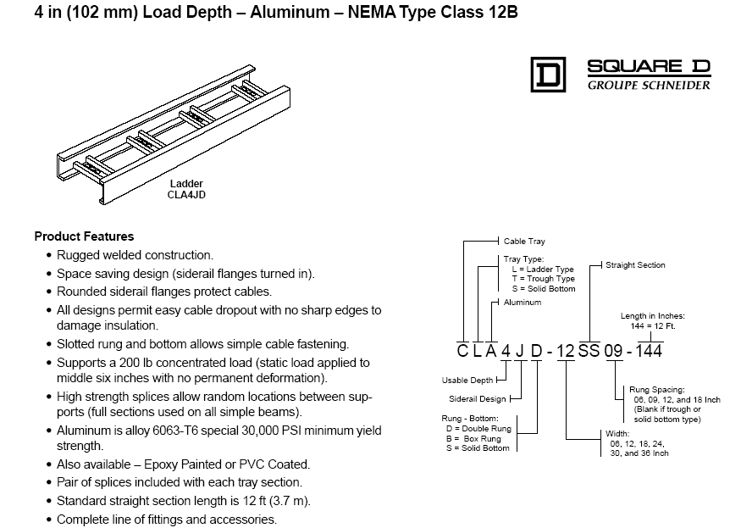

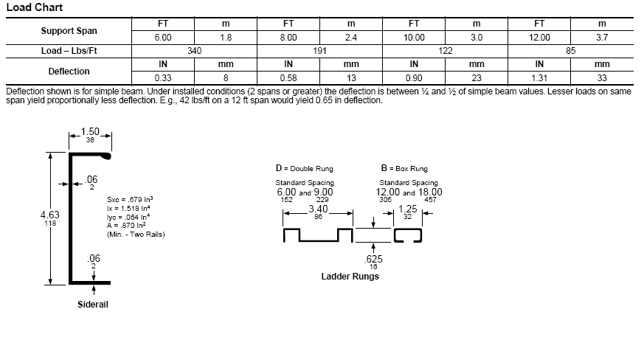

Editing Cabletray Spec

Spec Name | SD-CLA4JD-12-12B
Run Spacing | 6”
NEMA | 12B
Material | Aluminum
DefaultBendRadius | 12 inches
Traylength | 144 inches
PreferredGap | 0.375 inches

- Open the CabletraySpec worksheet.
- Add the following data in the columns noted for the new cabletray specification.

